VCP Pairing LAB
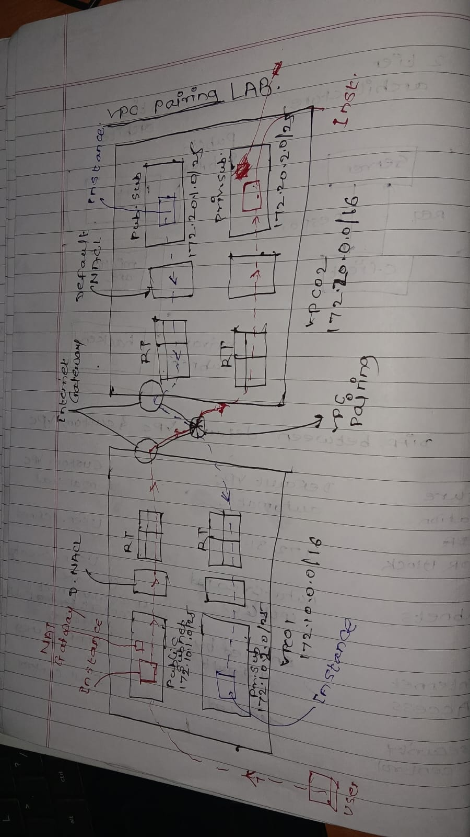

- Create 2 VPC
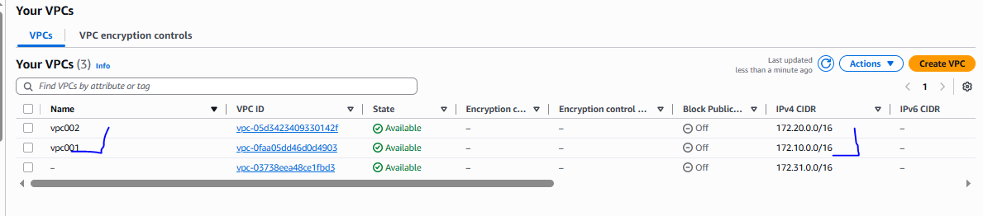
- Create a subnets (per VPC 2 subnet) total 4 subnet
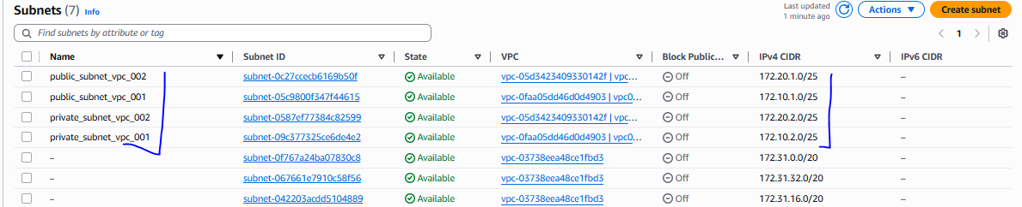

- Create a 2 internet gateway 2 VPC
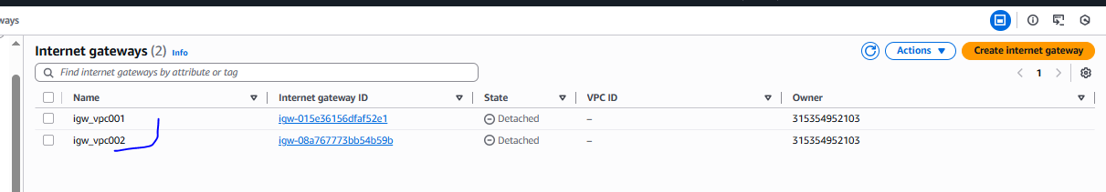
Once create the internetgateway please attached both to VPC respectively
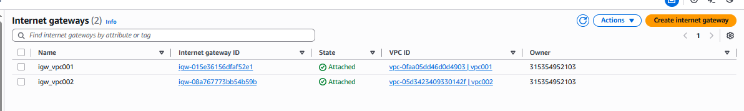

- Modify Public subnet –autoassign IP
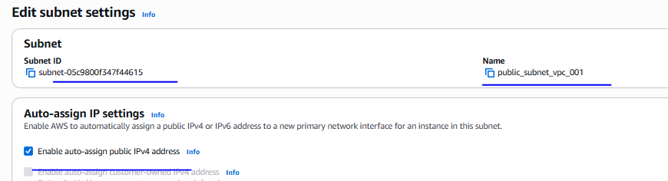
- Create a two NAT GateWay for 2 public subnets
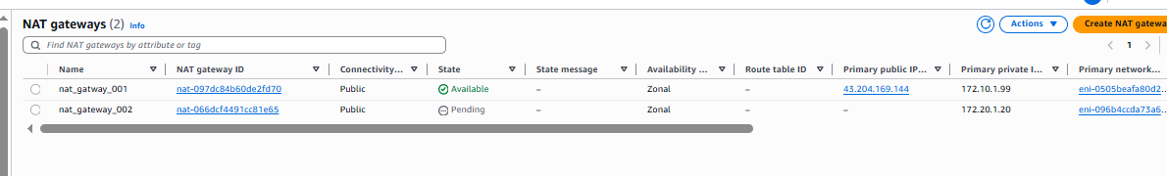
- Create a four route table (per VPC 2 route table)
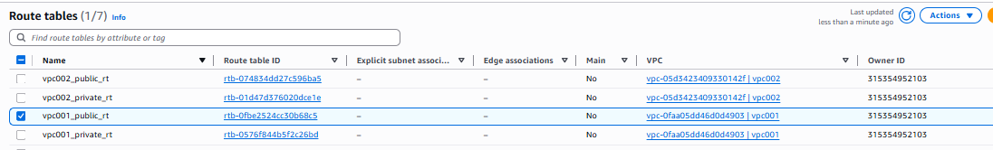

Once routes has been create need to configure with routes and subnet association for internet gateway and NAT Gateway
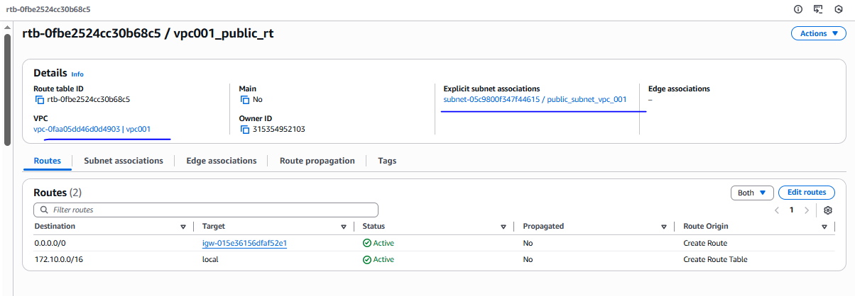
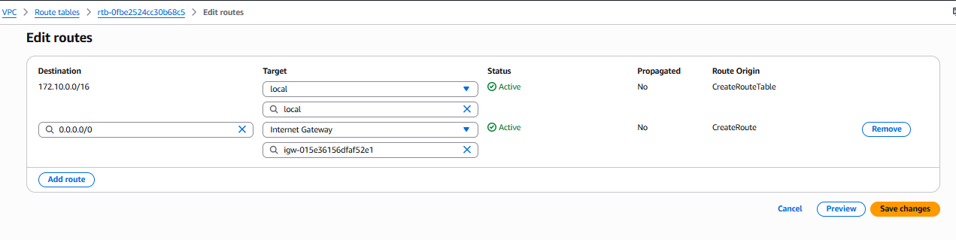
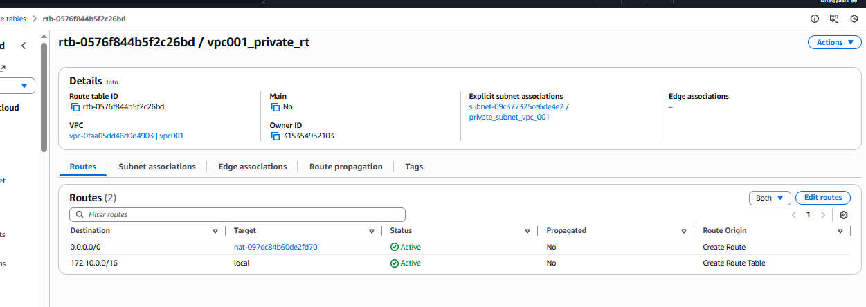
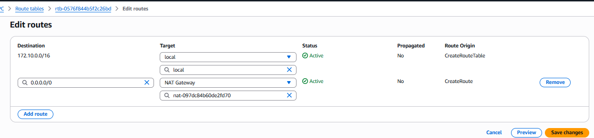

Similaraly do for vpc002 subnet also for both (public and private)
- VPC Pairing
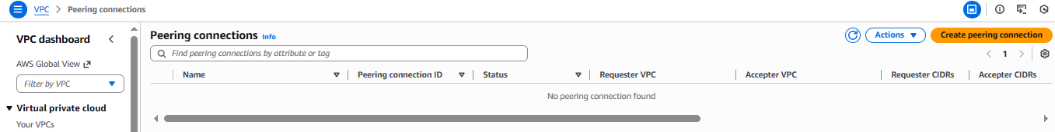
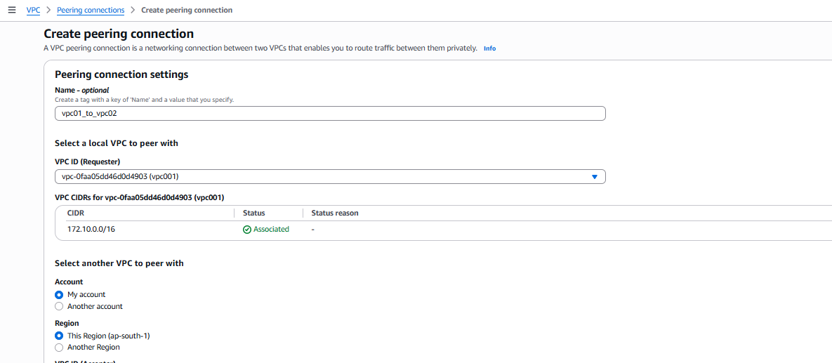

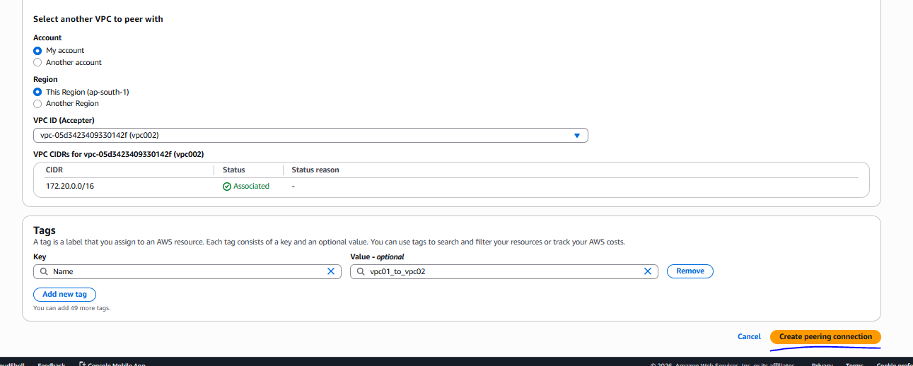

Once done VPC paring, need to do acceptance request
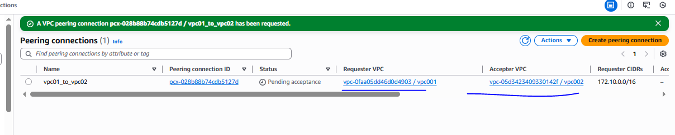

Accept the request as mention below
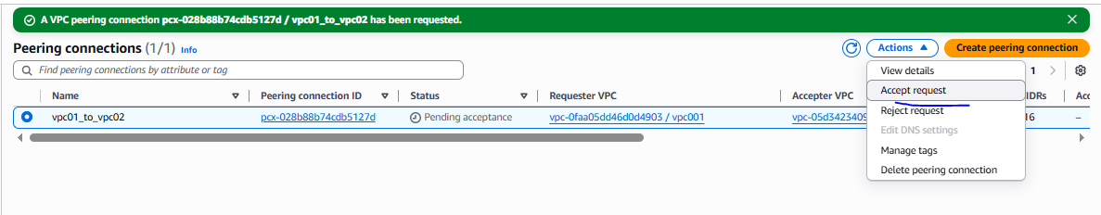
Active
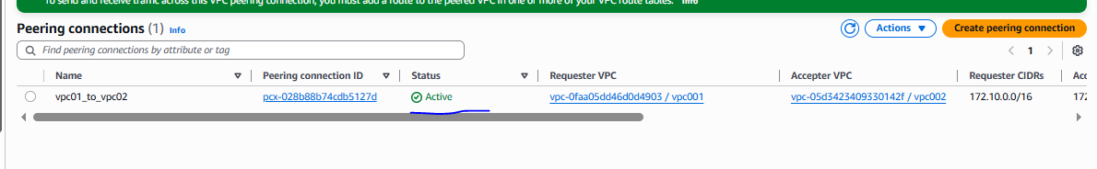
Only by the creating peering you will not able to communicate between two VPC we need to add the pairing between the subnet of both VPC

For this of VPC01 public route need to add entry and of VPC02 need to add entry private route table

We allow the entry of public route table(vpc01) on VPC02 pairing
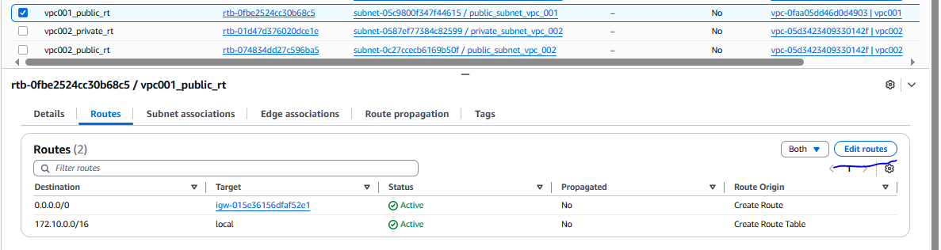
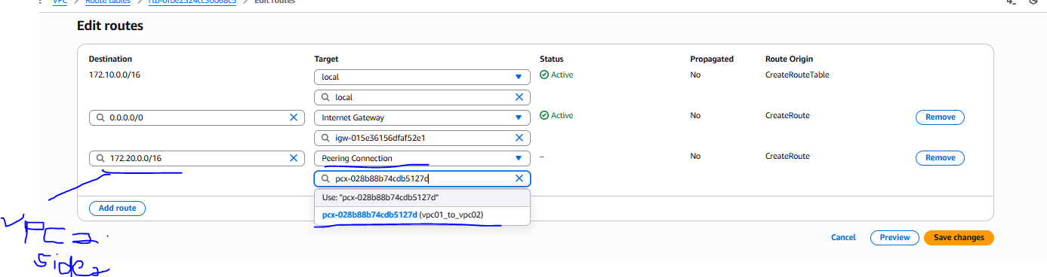

Similarly we need to allow the entry in private route table(vpc02) on VPC01 pairing.
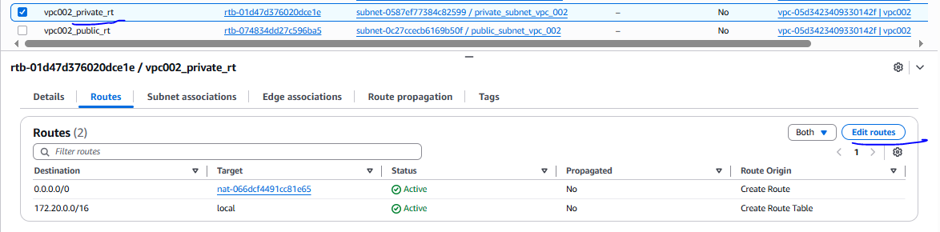
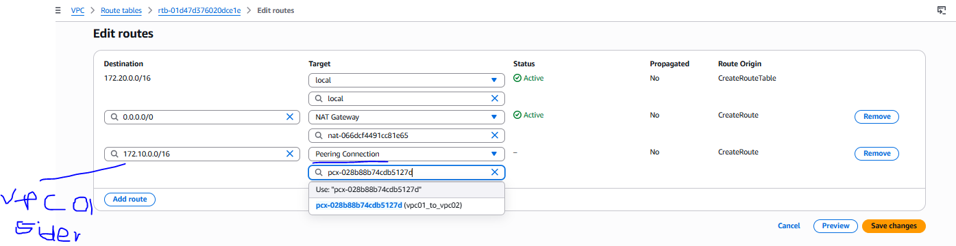

Configuration verified

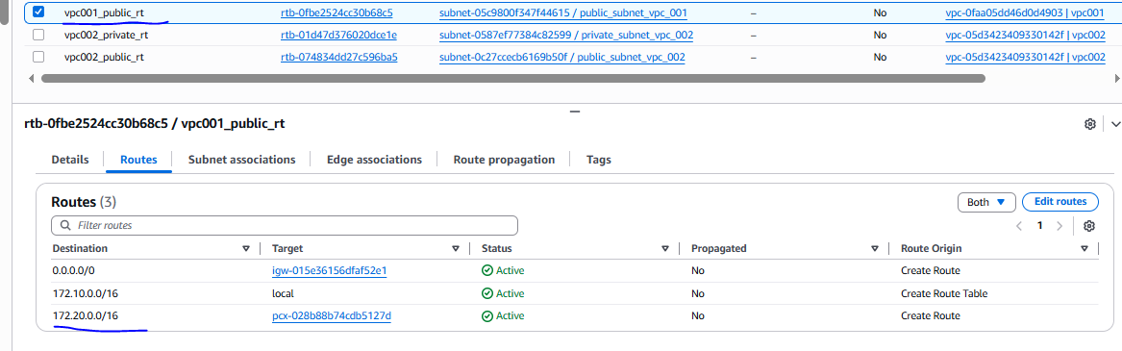
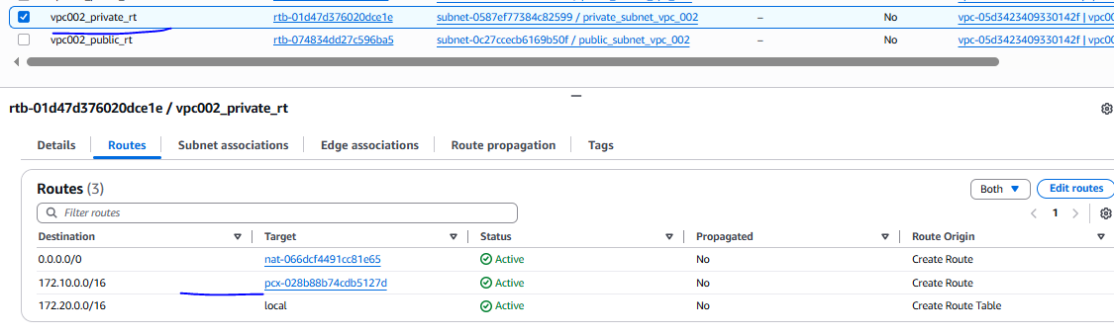
Once configuration done need to launch two instance 1 is public subnet of VPC 01 and 2nd is a private subnet in VPC02

Vpc 01 instance network setting
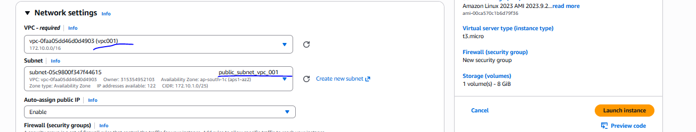

VPC02 instance network setting
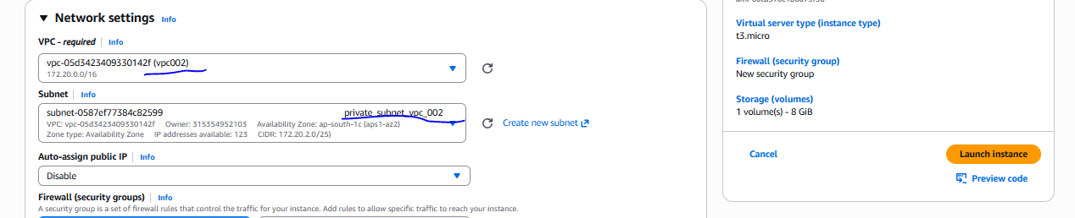

Instance has been created.
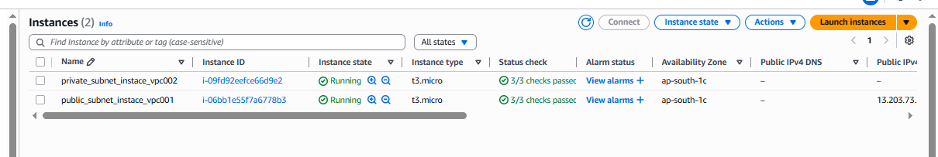
Final verification
Pubic subnet instance has been login and able to connect internet
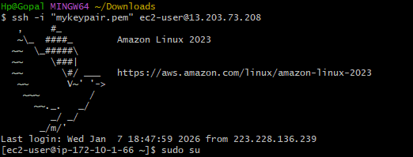
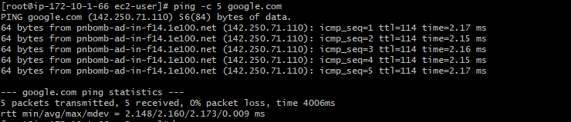
private subnet instance has been login and able to connect internet
